Assignment

Module 1: Understanding Hardware and Its Components

**Section 1: Multiple Choice**

1. Which of the following is NOT a component of the CPU?

a) ALU

b) RAM

c) CU

d) Both 1 and 3

Answer: b) RAM

2. What is the function of RAM in a computer?

Answer: RAM (Random Access Memory) is primarily used as temporary storage for processing tasks. It provides space to store data and program information temporarily.

3. Which of the following is considered a primary storage device?

a) HDD

b) SSD

c) SD card

d) Both 1 and 2

Answer: d) Both 1 and 2

4. What is the purpose of a GPU?

Answer: GPU is basically a Graphical Processing unit which process the graphics related tasks and improve the speed of program processes. it also increases the speed of rendering images, videos, and 3D objects.it also helps to perform high computation intensive tasks.

**Section 2: True or False**

5. The motherboard serves as the main circuit board of a computer, connecting and allowing communication between various components.

Answer: True

6. A UPS (Uninterruptible Power Supply) is a hardware device that provides emergency power to a load when the primary power source fails.

Answer: True

7. An expansion card is a circuit board that enhances the functionality of a computer component.

Answer: True

**Section 3: Short Answer**

8. Explain the difference between HDD and SSD.

Answer: **Difference Between HDD (Hard Disk Drive) and SSD (Solid State Drive)**

| **Feature** | **HDD (Hard Disk Drive)** | **SSD (Solid State Drive)** |
| --- | --- | --- |
| **Technology** | Uses spinning magnetic disks and a mechanical read/write head. | Uses flash memory with no moving parts. |
| **Speed** | Slower due to mechanical parts. | Much faster due to electronic circuits. |
| **Durability** | Prone to damage from shocks and vibrations. | More durable as it has no moving parts. |
| **Noise and Heat** | Produces noise and heat due to spinning disks. | Silent and generates less heat. |
| **Storage Capacity** | Available in larger capacities (up to 10TB or more). | Usually available in smaller capacities (up to 4TB). |
| **Cost** | Cheaper per GB, making it more affordable. | More expensive per GB but becoming more affordable. |
| **Power Consumption** | Consumes more power due to spinning disks. | Consumes less power, extending battery life in laptops. |
| **Performance** | Slower boot times, file transfers, and data access. | Faster boot times, quick file transfers, and instant access. |
| **Use Cases** | Best for storing large amounts of data at a low cost. | Ideal for operating systems, gaming, and fast applications. |

**Conclusion:**  
HDDs are more affordable and suitable for bulk storage, while SSDs offer faster performance, better durability, and energy efficiency. Due to their speed and reliability, SSDs are increasingly preferred for modern computers.

***9. Describe the function of BIOS in a computer system.***

Answer:

BIOS (Basic Input/Output System) is important software built into a computer's motherboard. It helps start the computer and checks that all hardware parts are working before the operating system loads.

**Key Functions of BIOS:**

**Power-On Self-Test (POST)**: Checks if essential hardware like the CPU and memory are functioning correctly and identifies any problems early.

**Bootstrap Loader**: Finds and loads the operating system from storage into RAM, ensuring necessary files are ready for startup.

**Software/Drivers**: Manages connections between hardware and the operating system, providing basic drivers needed during startup.

**CMOS Setup: Allows** users to change settings like time, date, boot order, and security features, storing these in memory that doesn't lose information when the power is off.

**Role of BIOS**:

It connects hardware and software by providing basic services, managing communication between different computer parts, and handling power efficiently.

**Importance**:

Without BIOS, computers can't start or work properly because it checks hardware, sets up system components, and loads the operating system. It also offers security features like boot protection.

In short, BIOS is essential for starting computers by checking hardware and configuring settings while linking software and hardware during use.

***10. List and briefly explain three commonly used input devices with computers.***

***Answer:***

1. **Keyboard:**
   * The keyboard is the primary input device for typing data into a computer.
   * It includes various types of keys such as alphanumeric, function, control, and navigation keys.
2. **Mouse:**
   * A mouse is a pointing device used to control the cursor on the screen.
   * It allows users to interact with graphical user interfaces by clicking, dragging, and dropping files or icons.
3. **Scanner:**
   * A scanner converts physical documents or images into digital format.
   * It captures images from paper and converts them into files that can be edited or stored on a compute

**Section 4: Practical Application**

11. Identify and label the following components on a motherboard diagram:

- CPU

- RAM slots

- SATA connectors

- PCI-E slot

Answer: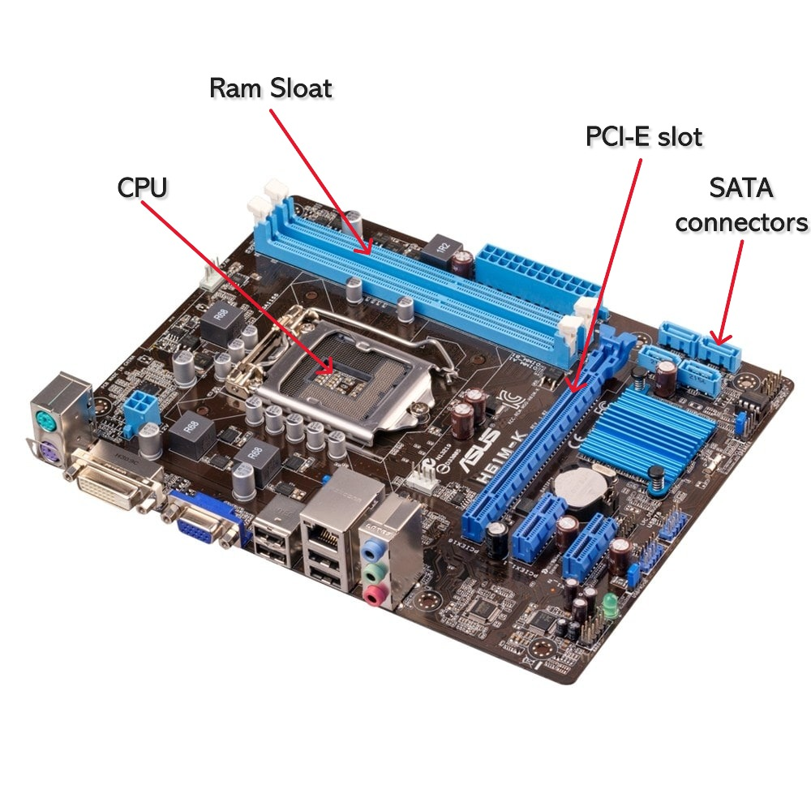

12. Demonstrate the process of installing a RAM module into a computer.

Answer: **Installing RAM (Memory) in a Computer**

1. **Power Down and Unplug:**
   * Ensure the computer is completely turned off and disconnected from the power source.
2. **Open the Computer Case:**
   * Remove the side panel of the computer case by unscrewing it and set it aside.
3. **Locate the RAM Slots:**
   * Identify the long, narrow slots on the motherboard where the RAM modules are installed.
4. **Prepare the RAM Stick:**
   * Hold the new RAM stick by its edges, avoiding contact with the metal connectors.
5. **Align the RAM Stick:**
   * Match the notch on the RAM stick with the corresponding notch in the slot.
6. **Insert the RAM Stick:**
   * Press the RAM stick gently but firmly into the slot until you hear a click.
7. **Secure the RAM:**
   * The side clips of the slot should automatically snap into place, holding the RAM securely.
8. **Close the Computer Case:**
   * Reattach the side panel of the case and secure it with screws.
9. **Reconnect and Power On:**
   * Plug the computer back in, turn it on, and verify that the new RAM is detected and ready for use.

13. Discuss the significance of proper cooling mechanisms in a computer system, including examples of cooling methods and their effectiveness.

Answer: computer systems generate substantial heat due to the high-speed operations of components like the CPU, GPU, and power supply unit. Without effective cooling mechanisms, this heat buildup can degrade performance, shorten hardware lifespan, and cause system failures. Proper cooling prevents these issues, ensuring that the system runs efficiently without performance throttling.

**Significance of Proper Cooling Mechanisms in a Computer System**

Cooling mechanisms play a vital role in maintaining the performance, stability, and longevity of a computer system. When components like the CPU, GPU, and power supply operate, they generate heat. Excessive heat can lead to overheating, which causes system slowdowns, unexpected shutdowns, and permanent damage to hardware components. Proper cooling prevents these issues, ensuring that the system runs efficiently without performance throttling. It also extends the lifespan of components, reducing the risk of hardware failure and repair costs.

**Examples of Cooling Methods and Their Effectiveness**

1. **Air Cooling:**
   * **Description:** This is the most common cooling method, where fans are used to circulate air and dissipate heat from components.
   * **Effectiveness:** It is cost-effective and easy to maintain but may not be sufficient for high-performance systems or intensive tasks like gaming or video editing.
2. **Liquid Cooling (Water Cooling):**
   * **Description:** Liquid cooling systems use coolant to absorb heat from components, which is then dissipated through a radiator.
   * **Effectiveness:** This method is highly efficient, especially for gaming PCs and servers. It is quieter and more effective than air cooling, making it ideal for overclocked systems.
3. **Thermal Paste:**
   * **Description:** Thermal paste is applied between the CPU and the heatsink to fill air gaps and improve heat transfer.
   * **Effectiveness:** It is essential for maintaining proper heat dissipation and preventing the CPU from overheating.
4. **Heat Sinks:**
   * **Description:** Heat sinks are metal components with fins that absorb heat from hardware components and dissipate it into the surrounding air.
   * **Effectiveness:** They are reliable, maintenance-free, and commonly used in CPUs and GPUs, but they are less effective than active cooling methods.

14. Explain the concept of bus width and its importance in computer architecture.

Answer:

**Bus Width in Computer Architecture:-**

In computer architecture, **bus width** refers to the number of bits that a bus can transmit simultaneously. A bus is a communication system that transfers data between components inside a computer, such as the CPU, memory, and peripherals. Bus width is typically measured in bits, with common sizes including 8-bit, 16-bit, 32-bit, and 64-bit buses.

**Types of Buses**

* **Data Bus:** Transfers actual data between components. The width of the data bus directly affects how much data can be transmitted at once.
* **Address Bus:** Carries the addresses of memory locations that the CPU wants to access. Its width determines the maximum amount of addressable memory.
* **Control Bus:** Sends control signals to manage data flow and device operations.

**Importance of Bus Width**

1. **Data Throughput:** A wider data bus allows more data to be transferred in a single clock cycle, increasing overall system performance. For example, a 64-bit data bus can transfer eight times more data per cycle than an 8-bit bus.
2. **Memory Addressing:** The width of the address bus determines the maximum amount of memory a system can use. For instance, a 32-bit address bus can address up to 4 GB of memory, while a 64-bit address bus can address 18 exabytes.
3. **System Speed:** With a wider bus, fewer cycles are needed to transfer large amounts of data, reducing latency and improving speed.
4. **Compatibility and Performance:** The bus width must match or be compatible with other hardware components. A mismatch can limit system performance even if other parts are advanced.

In modern computer systems, increasing bus width has been crucial in supporting advanced applications and large datasets, ensuring faster data transfer and more efficient memory usage. This enhancement is essential for improving both computational speed and overall system performance.